COVID-19: Tips on how to support our children/youth and each other
March 13, 2020

COVID-19, aka novel Coronavirus, has dominated the news and social media for months and now it is in our backyard! There have been varying schools of thought, some grounded in science, some logical and some promoting fear. We have heard them all! On March 12, 2020 the Ontario Minister of Education shared that schools in Ontario will remain closed for an additional two weeks following the March academic break, that is scheduled to start Monday March 16, 2020. This was not planned, so what do we do now?
How do we talk to our kids about COVID-19?
I think it is fair to say that most children/youth are going to be elated for the extra time off, however, as parents and caregivers we know that this change in routine has the capacity to reek havoc in our lives!

The first thing we must do is check in with ourselves. How do we feel about this unprecedented change? What are our fears, anxieties and worries? It is important to understand that this will be traumatic event for many people, as trauma violates a person's capacity to feel safe in response to a disturbing or distressing event. The way we respond to a traumatic event has direct implications for ourselves, our children/youth, and each other. In recognition of this, connection and nurturance, primal human needs, serve as the foundation for resilience as we walk through this together.
Prior to talking to your child/youth:
- Spend some time reflecting and identify your thoughts and emotions.
- Talk to a support person about your feelings and worries openly, however, ensure you are not in the presence or proximity of your child/youth as you do so.
- We do not have all the answers, and that is okay. Find solace in the present and work from there.
- Develop your plan, and/or create an outline of plan of things you need to do to respond to this situation (i.e. financial, employment, child care, food, medical etc.).
- Identify your “team”. Who are your support persons?
- Develop a script of what you want to say to your children/youth if you are anxious.
Talking to your child/youth:
- Youth/teenagers are often categorized as ‘adult like’, however, it is important to remember that the adolescent brain is not fully developed (brain development continues into mid-late 20’s), and therefore youth too require our support, although we can count on them to assist in practical ways that younger children cannot.
- Be grounded. Children/youth look to us to make sense of the world and feel secure. If we are dysregulated and scared, we promote the same for them.
- Our verbal, non-verbal, and emotive reactions are palpable and important to understand as they impact the way we interact with others and how those interactions are received and perceived.
- It is okay to say we do not know and you do not have all the answers.
- Be truthful, without inciting fear.
- Don’t give power to the “what if’s”. Children/youth will have questions, as we all do. Our wonderful brains are hard wired to future predict in an attempt for self preservation, create a sense of control, or to avoid pain, rejection or distress. When we catch ourselves, or our children/youth, becoming overwhelmed with future predicting thoughts and worries it is important to and remain grounded in present moment and shut these thoughts down, as they can be counterproductive. Excessive worry does not serve.
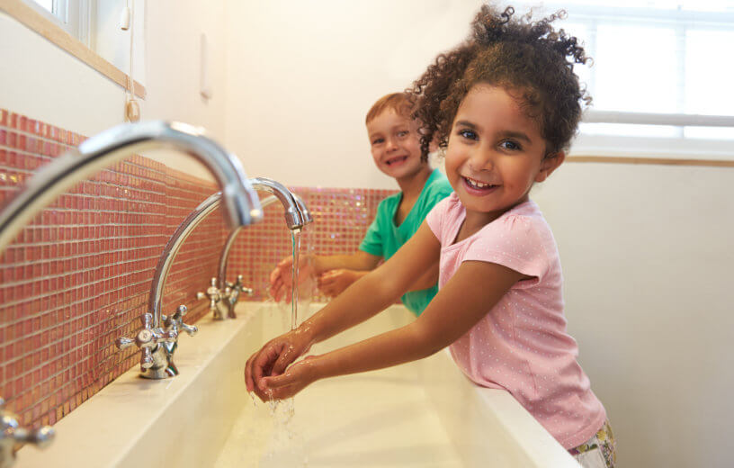
- Promote hand washing. It is fair to say, many of us, in our day to day lives, do not practice proper hand washing techniques, as promoted and easily found online through the World Health Organization (WHO). A tip that I learned from kindergarten teachers, which I may add I have my teenagers currently following, is posting the picture in the washroom of proper handwashing techniques and while you’re washing your hands sing “twinkle, twinkle little start”. When singing at a regular pace it takes around 30 seconds to sing the song once through. The WHO’s suggested time for proper handwashing is 60 seconds, therefore teaching ourselves and our children/youth to sing the song twice, while lathering our hands, will reinforce proper hand washing, which is of incredible importance, in a fun, interactive, non-fear based way.
The importance of routine:
Our lives are driven by routine and COVID-19 has put a serious wrench in that! Moving into March break we are naturally out of our regular routine, but for the additional weeks many of us are not sure what the routine will be. We all find solace in routine, so try and create routine in the upheaval we’re experiencing the best you can.
- Develop a new routine.
- Adhere to bedtimes, naps, etc. for younger children.
- Ensure everyone is getting proper sleep, as sleep helps keep our immune systems strong.
- Visual schedules are helpful tools for promoting predictability, and there are many examples readily available online. Involving younger children in the creation of a visual schedule (calendar with pictures and words) helps to promote a sense of security.
- Youth may not want to assist in the creation of a visual schedule; however, they do reap the same benefits from this tool, particularly since their executive functioning is not fully developed.
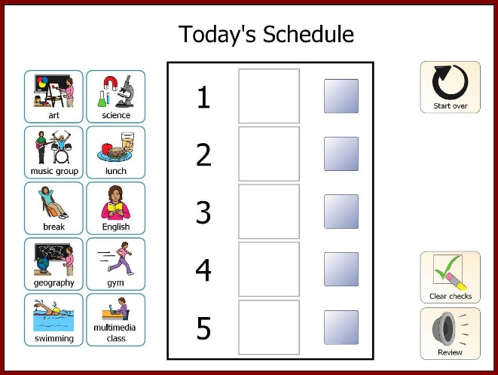
Example of a visual schedule

- Have household tasks to do.
- Draw pictures or use real life pictures of people who will be assisting in the children/youths care.
- Plan mealtimes together. This supports connection, social emotional wellbeing, and reduces stress within families.
- Get out the board games and art supplies. Support literacy and numeracy in your play.
- Incorporate movement into your day, may it be home exercises, dancing, stretching or even twister!
- Get fresh air daily, minimum of 20 minutes, even if it is sitting in your backyard.
- Find laughter! The power of laughter, even at the “darkest” of times has a miraculous capacity to reduce our stress.

Community Connection:
Upon learning of schools closing for an additional two weeks my first thought was “what about the families in need?”. Social Workers, and others in helping professions, across the province know the prevalence of poverty in our communities. I can attest that it is often hidden! Many people are living pay to pay to keep themselves and their families above water.



In the village I come from, in rural PEI, we instinctively rally together and support all in need, may it be a house fire, flood, disability, illness etc. There is a sense of community accountability and responsibility for each other rooted in the reality that we are all connected, and we all have something of value to contribute. We can do this here as well through our faith based connections, extra-curricular teams, colleagues, friends, family, neighbours, etc.

There are children/youth and families in need in all communities. There are many children in our schools that get their primary daily food intake at school and this is a reality that is seldom spoken. This is NOT due to parental neglect; it is the harsh reality of underemployment, that despite working one or more jobs, families often do not have enough money. If you know of a family in your area, or even suspect, offer what you can.

Look to your community network and how you can support each other during this transition, even if you haven’t done so in the past. This is important to look at as daycare costs can be an astronomical unplanned expense. Seek out opportunities to support each other. Again, my country roots are showing! This is a time for us to be grounded in our humanity and support each other and OUR children/youth. We are in this mess together, and together we will prevail. I am assuming that the government will kick in an assist, as we have witnessed in many other countries around the world who have been impacted by COVID-19, however, that is only one piece of the puzzle and we do not have those assurances at present.

